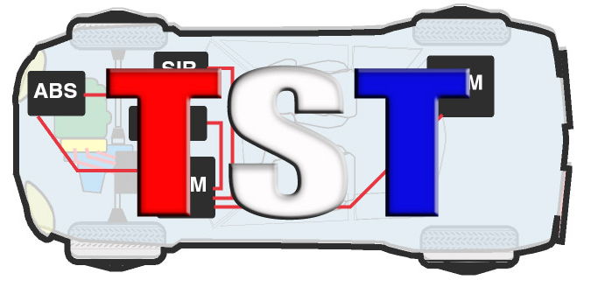
Technicians Service Training

"The Seventeenth Annual TST Tech Training Big Event"

Event Date: Saturday, August 15th, 2020 - Event starts at 8 AM to 6:30 PM
(Attendee check-in starts at 6:30am)

Location: Westchester Marriott 670 White Plains Road, Tarrytown, NY 10591
#800 882-1042

COMPANY NAME: ____________________________________________________________________

ADDRESS: ___________________________________________________________________________

TEL. #:__________________________ EMAIL: _____________________________________________

$2500.: Bronze Sponsorship - 3 representatives,
$100. ea. additional rep.

Representative’s names attending event: (Please Print):

- _________________________________________
- _________________________________________
- _________________________________________

ADDITIONAL REPRESENTATIVES:
___________________________________ ______________________________________
___________________________________ ______________________________________

PAYMENT INFORMATION: (FOR ADDITIONAL REP

Credit Card #____________________________________ Exp. Date: _______ Sec. #____________

Name as it appears on credit Card: _____________________________________________________

Authorized Signature: ________________________________________Total Amount: ____________

If paying by check: TST 11 Lupi Plaza, Mahopac NY 10541

Please return form: - Email : doreen@tstseminars.org – fax. 845 628-9109

This event will be presented snow, rain or shine, NO REFUNDS!

