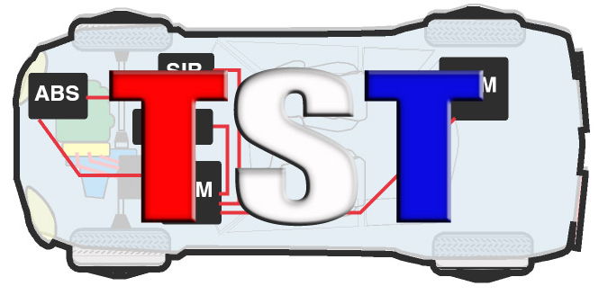

*Technicians Service Training*

"The Annual TST Tech Training Big Event & Trade Show"

Event Date: Saturday, March 28th, 2026- Event starts at 8:00 AM to 6:30 PM

*(Attendee check-in starts at 6:30am)*

Location: Westchester Marriott 670 White Plains Road, Tarrytown, NY 10591

#800 882-1042

COMPANY NAME: ____________________________________________________________________

ADDRESS: ____________________________________________________________________________

CELL:__________________________ EMAIL: _____________________________________________

*$1,000. 1-6 x 6 Ft. Table 2 Representatives*

*Additional Representative $200. ea. (Max 4 Total)*

Representative’s names attending event: (Please Print for name Badge):

1. _________________________________________
2. _________________________________________

ADDITIONAL REPRESENTATIVE:

1. _________________________________________
2. _________________________________________

*Please email form to* [*doreen@tstseminars.org*](mailto:doreen@tstseminars.org) *- Any questions call 845 628-1062*

*This event will be presented whether Snow, Sleet, Rain or OTHER!*

*--NO REFUNDS--*